線上問卷操作流程
Online questionnaire filling steps

- 連結線上問卷網址或掃QR code
Link to the online questionnaire URL or scan the QR code

http://onbl.wemecool.com/EQA 授權碼(Authorization code)：37ortnbw

- 進入頁面，並鍵入身分證字號(因未提供，請輸入生日的西元年月日，如19681119，共8碼)
Enter the page and Please enter ID number to log in

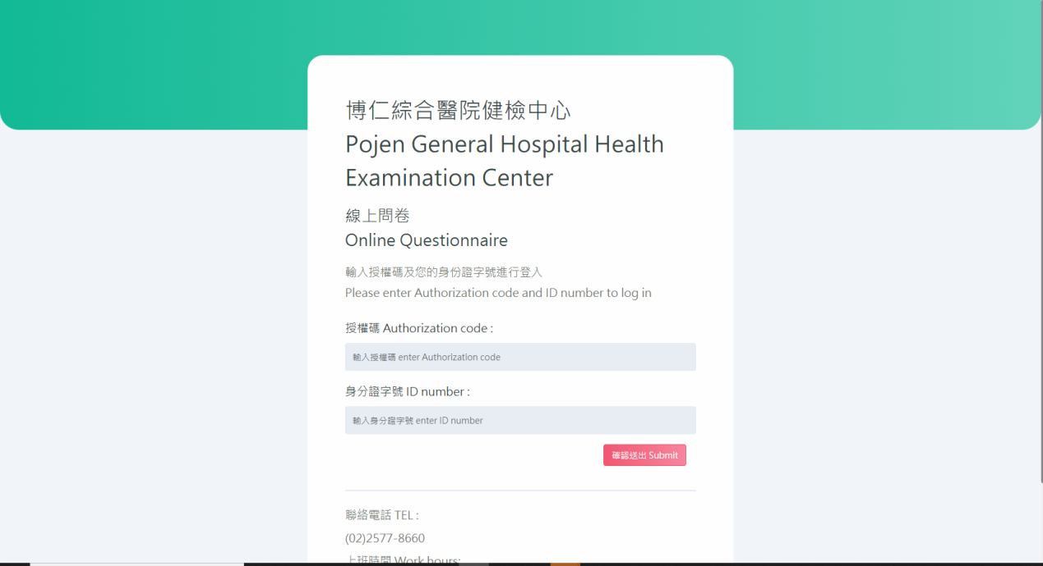

3.進入基本資料畫面，核對基本資料，並填上電話和電子信箱
Enter the basic information page, check the basic information, and fill in the phone and e-mail

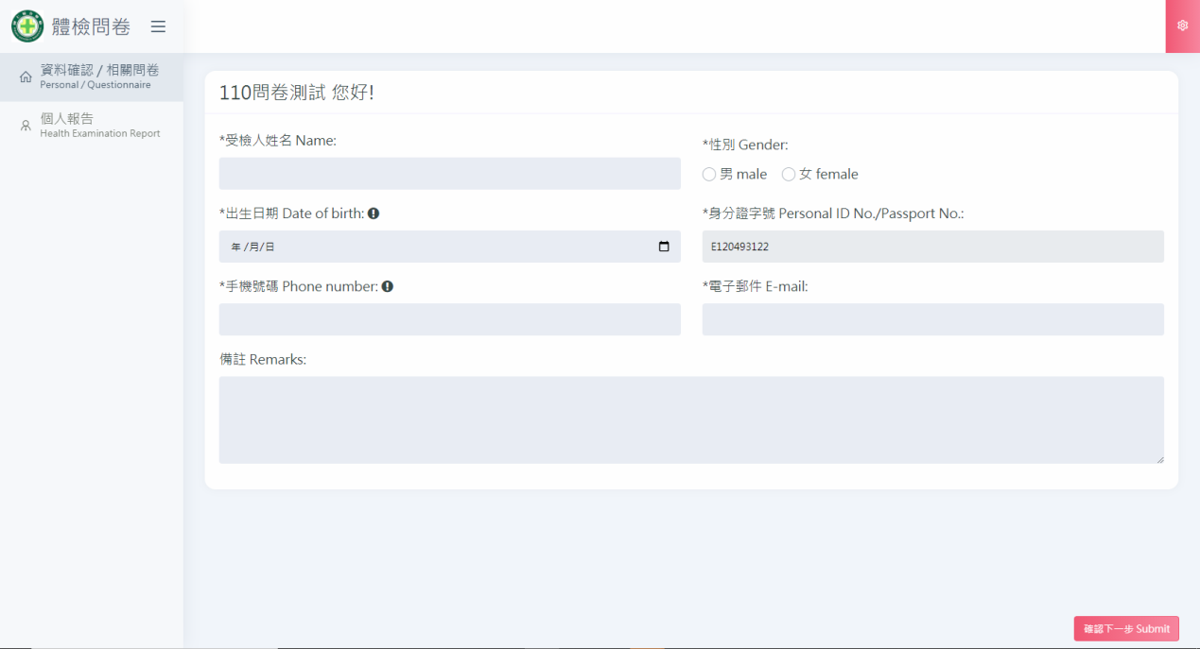

4.確認後，請按下右下角確認下一步，進入問卷畫面，開始填寫(每個問卷都必須填寫)
After confirming, please press the lower right corner to confirm the next step, enter the questionnaire page, and filling in (each questionnaire must be filled in)
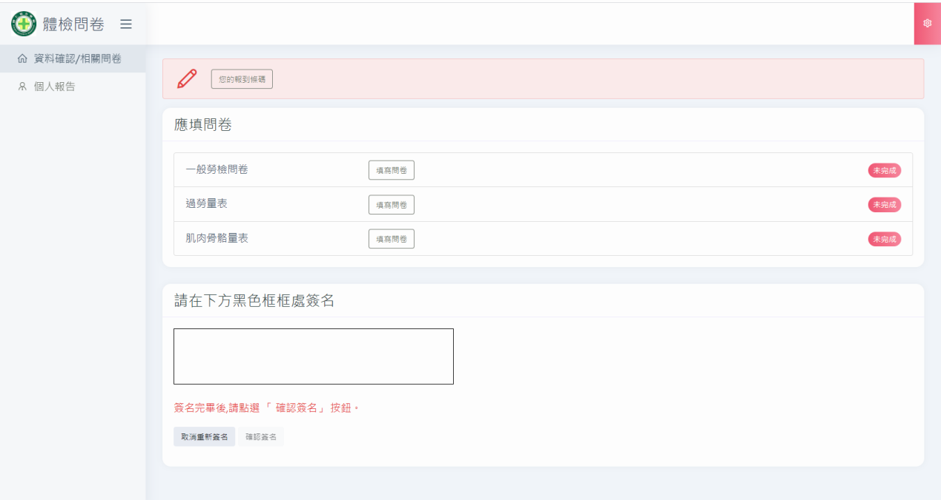

5.填寫完成後必須按下右下方的儲存才算完成
After completing the filling, you must click the save at the bottom right to be considered complete

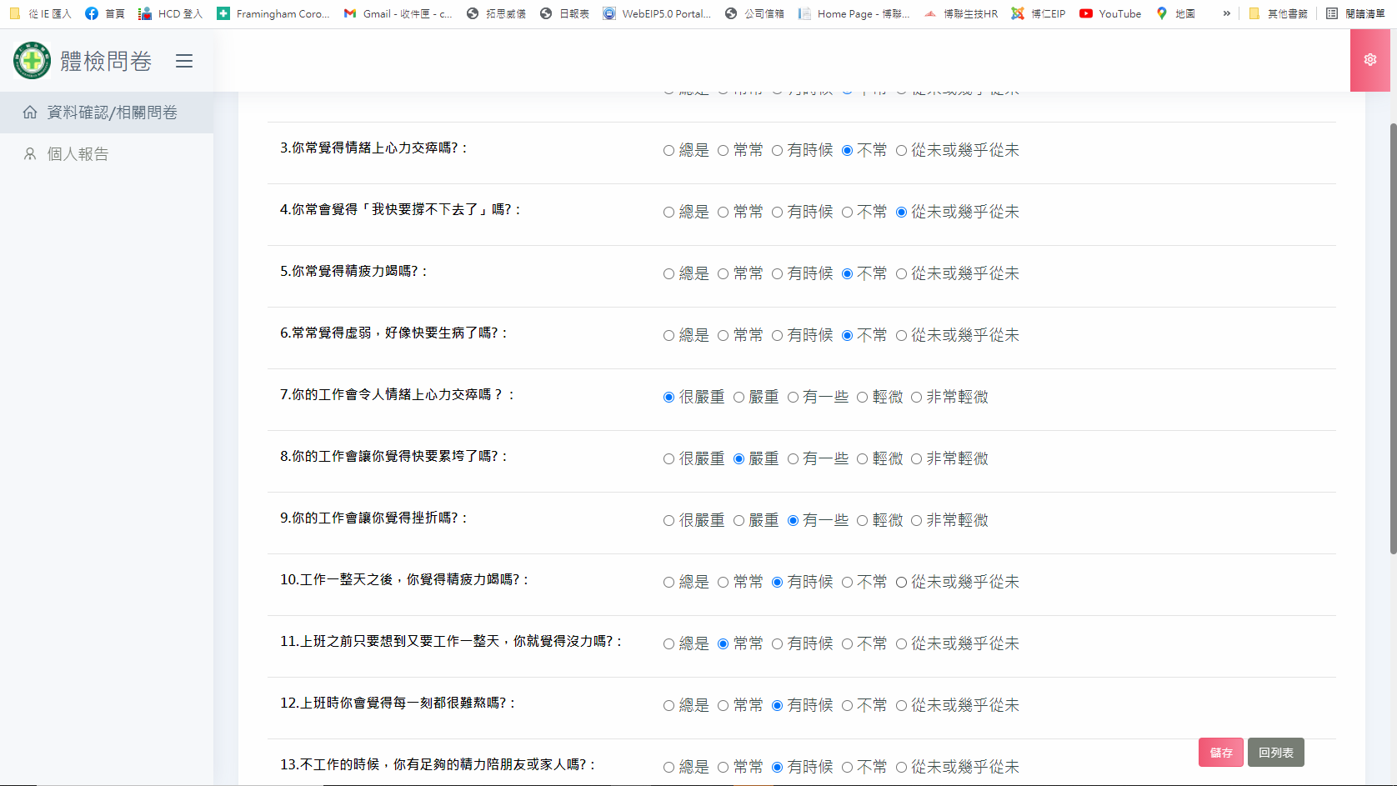

6.填寫完成的問卷會在每個問卷右側會顯示已完成
Each completed questionnaire will show completed on the right side of the questionnaire

